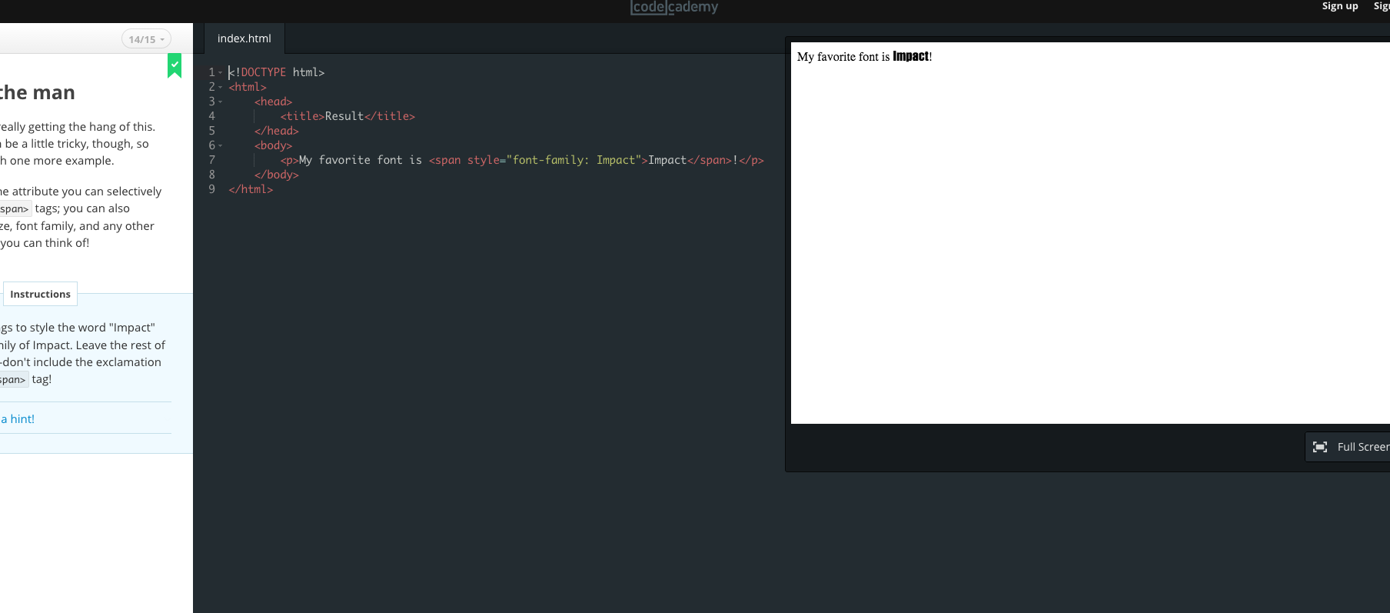

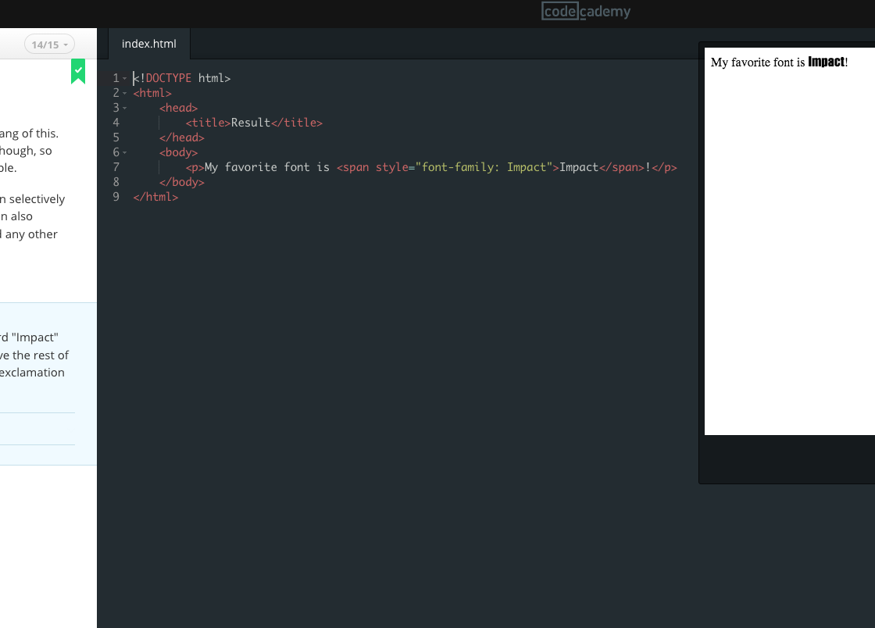

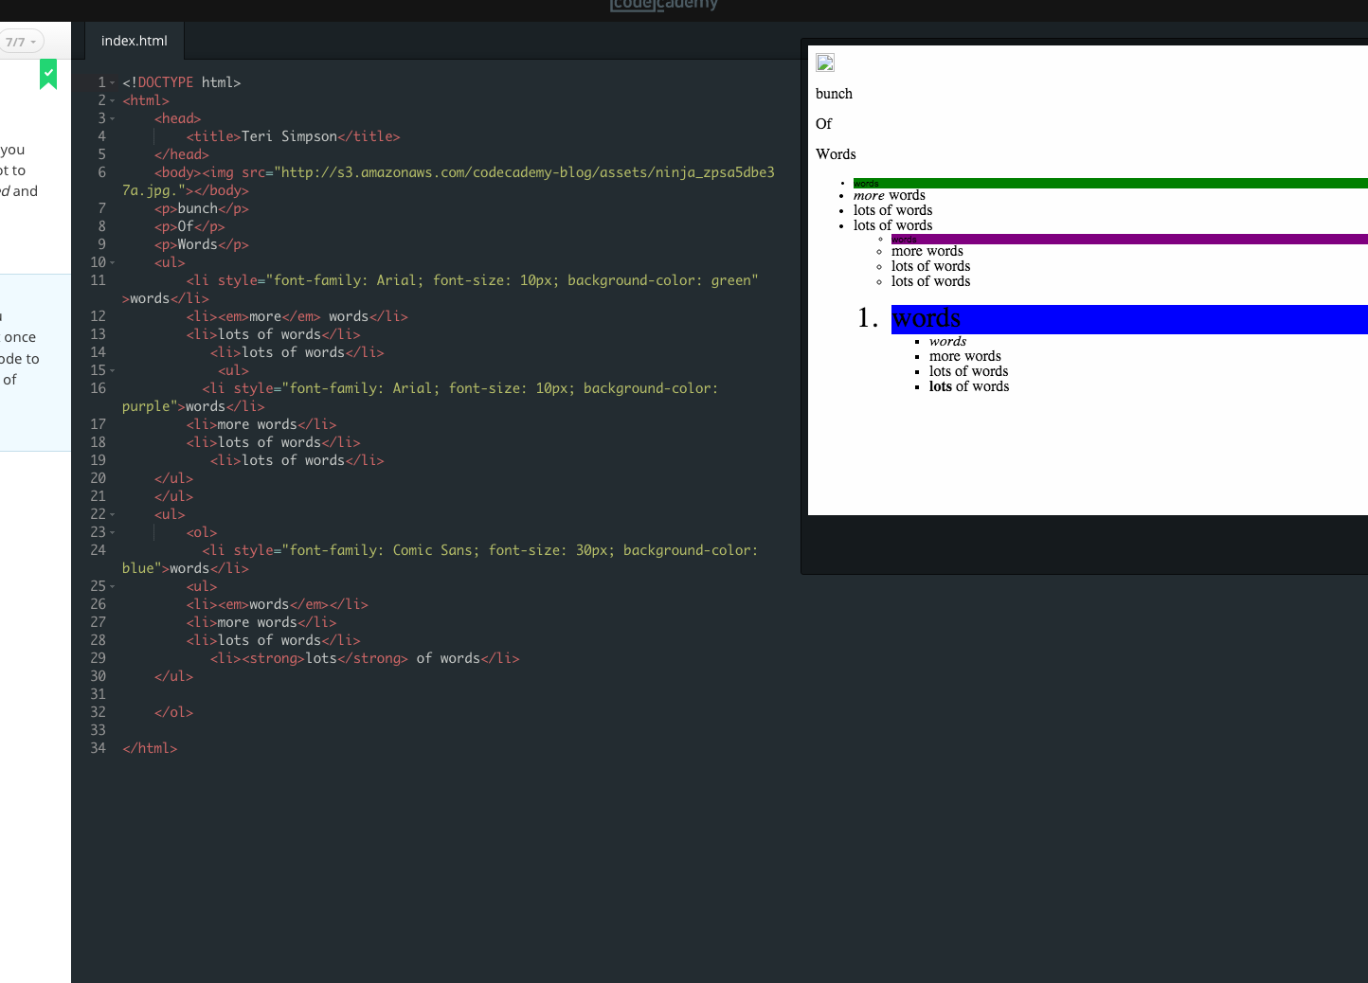

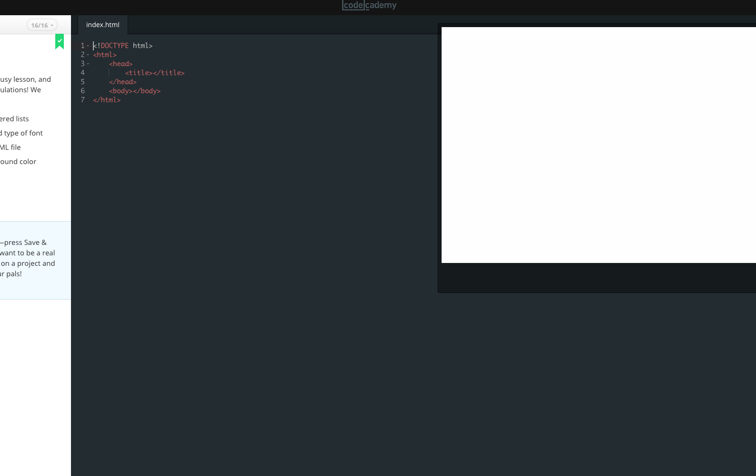

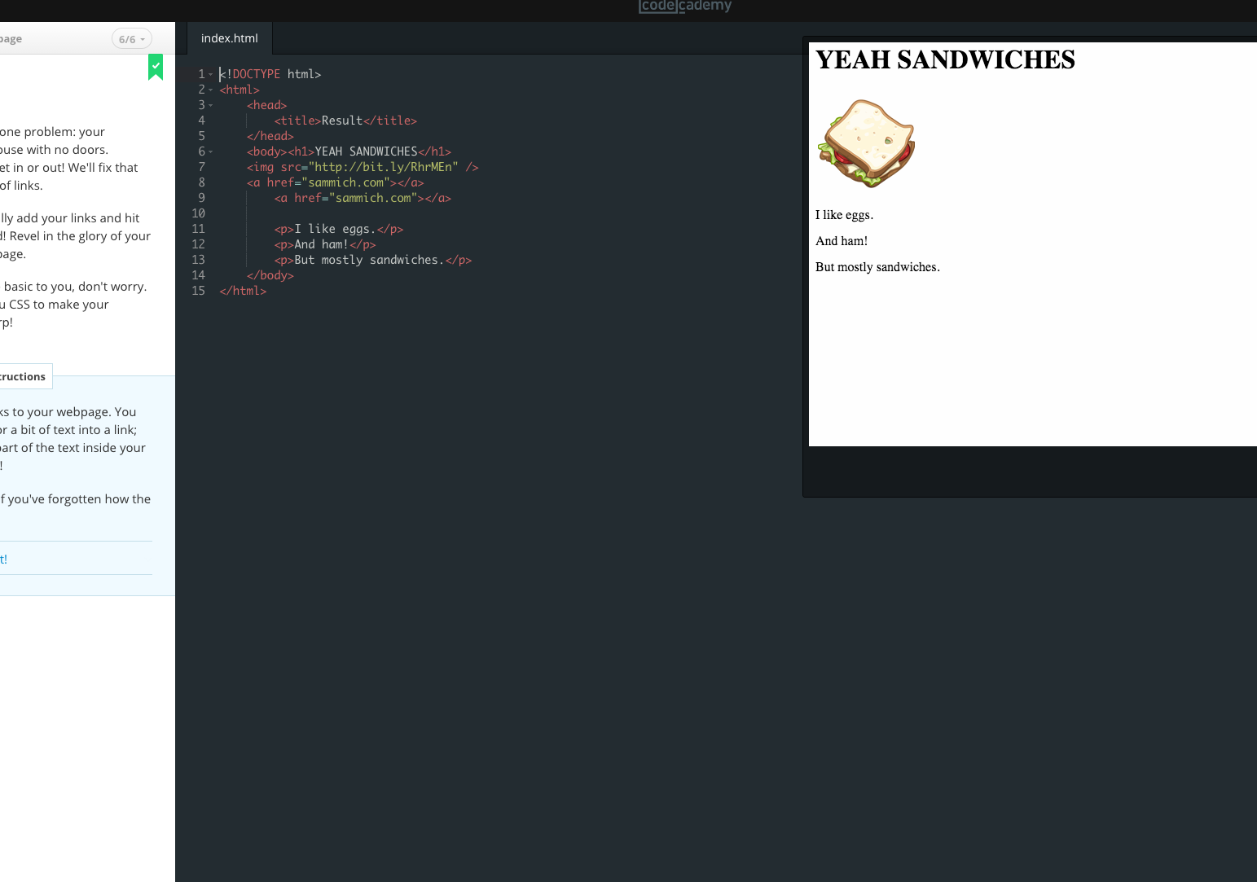

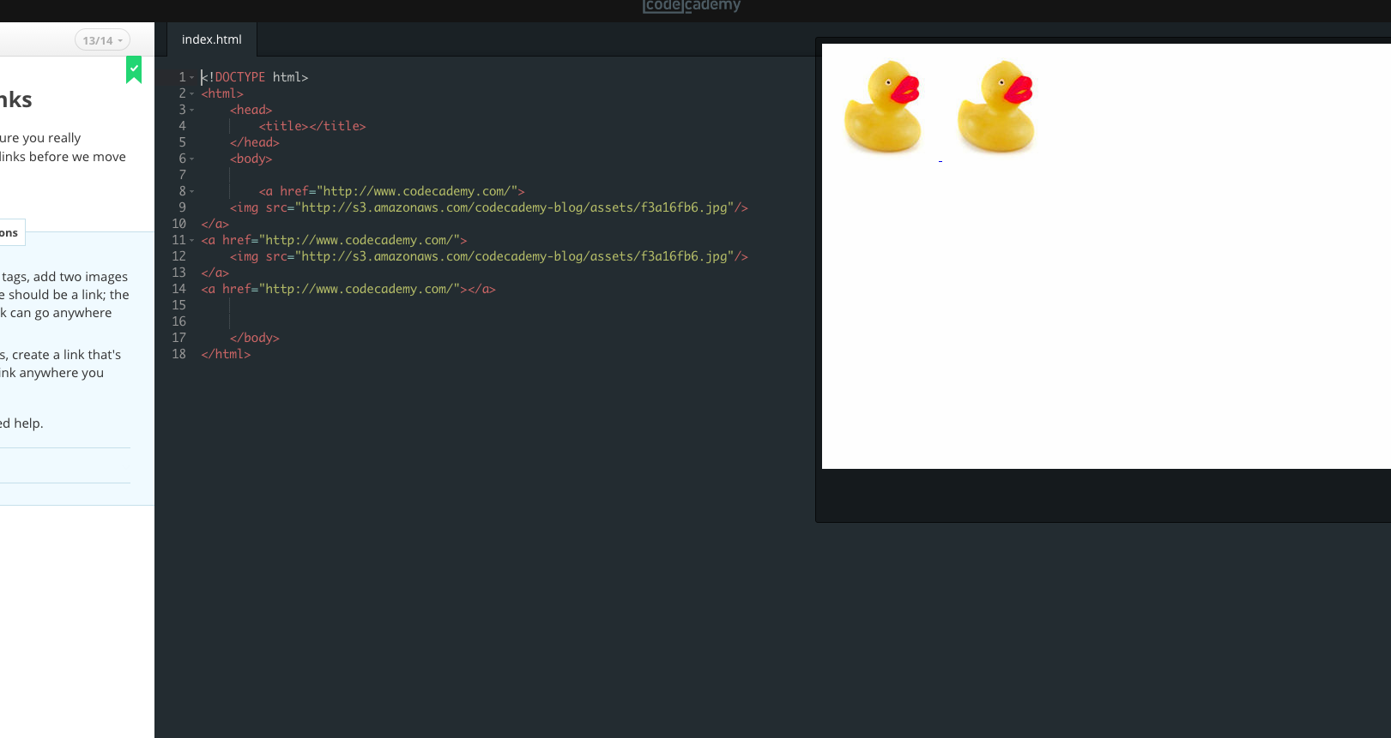

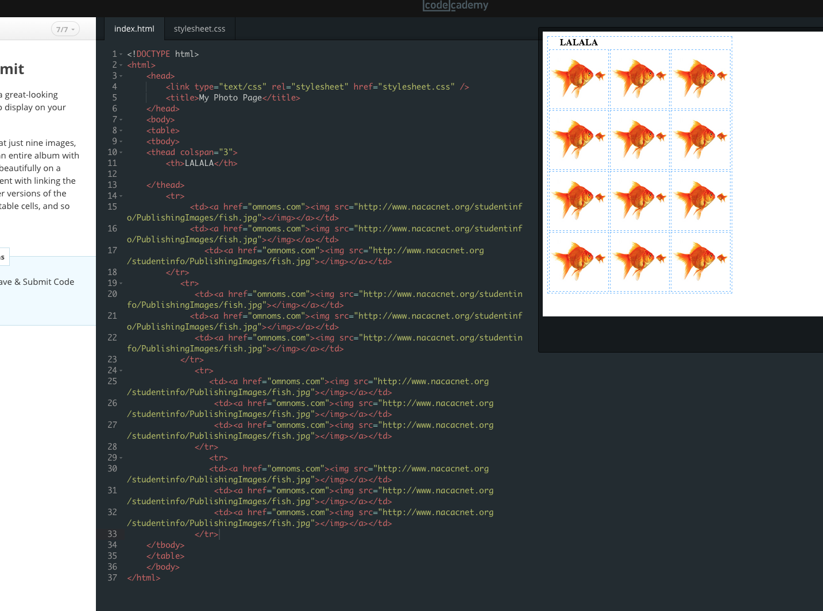

1. What did you learn from the HTML AND CSS Code Project?

Finally I understand the structure of unordered and ordered lists inside of heads. I did not understand it before. I learned to be very careful with my li styles. I wanted to put styling after column lengths and couldn’t figure out why I couldn’t just put them together. Also I want to put background color and just color into elements as just color, but those are two separate things.

1. What was interesting? How do you see yourself using this?

The tables are very useful to learn. I will be making many of them. I am still just learning the cascading structure of elements and their organization. With patience and diligence you can make a beautiful page from scratch!

1. Post your response here on the Canvas assignment (upper right corner in this assignment area)

I will be using Github and Sublime text for my web site. I hope it all uploads ok tomorrow.